C PROGRAMMING
NAME : YOKITHA S
ROLL NO: 241801327
WEEK:9
TOPIC:TWO DIMENSIONAL AND MULTI DIMENSIONAL ARRAY
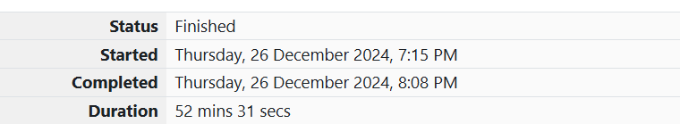
1. Problem Statement:
You are given a two-dimensional 3×33 \times 33×3 array starting from A[0][0]A[0][0]A[0][0]. You need to find the sum of alternate elements (even-indexed and odd-indexed separately) and print them.
Input Format:
A 3×33 \times 33×3 matrix of integers.
Output Format:
Print two integers in separate lines representing the sum of elements at even and odd positions respectively.
Sample Input:
Copy code
1 2 3
4 5 6
7 8 9
Sample Output:
Copy code
25
20

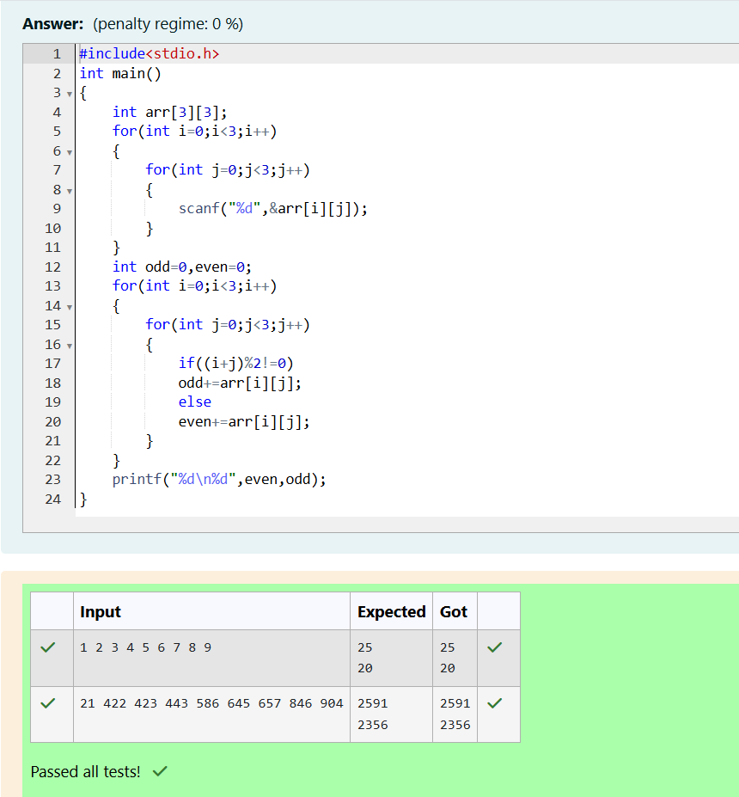
2. Problem Statement:
A company is conducting interviews for various positions. Each candidate is assigned a priority based on their qualifications. Your task is to arrange the candidates in non-increasing order of their priority and output their names.
Input Format:
The first line contains an integer NNN—the number of candidates.
The next NNN lines contain a candidate's name (a string) and their priority (an integer) separated by space.
Output Format:
Print the names of candidates in the order of their priority.
Constraints:
1 ≤N≤105\leq N \leq 10^5≤N≤105
Names contain only lowercase English letters and have at most 20 characters.
Priorities are integers between 1 and 10610^6106.

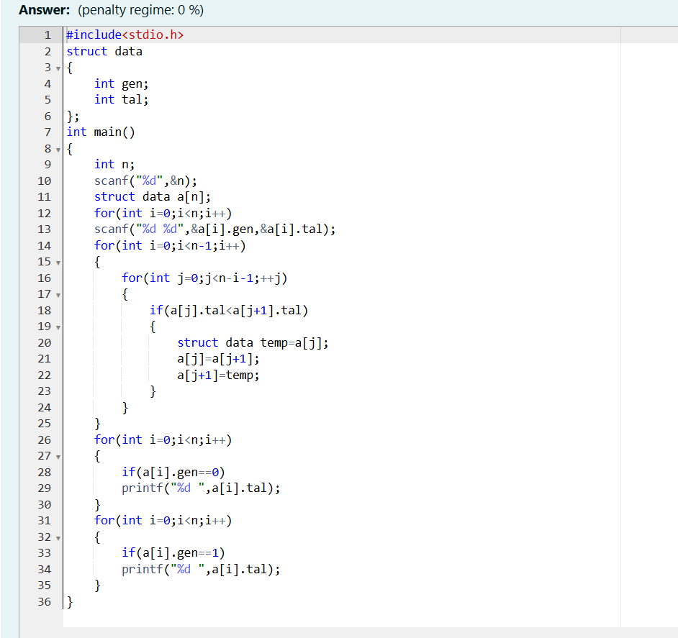
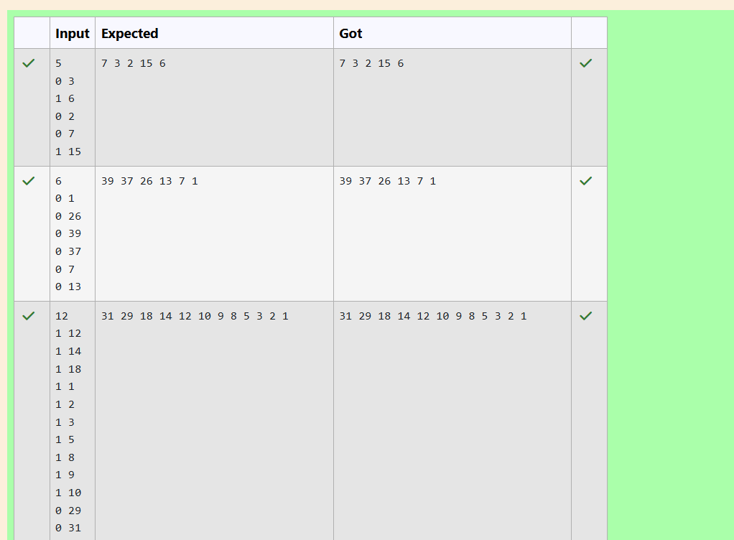
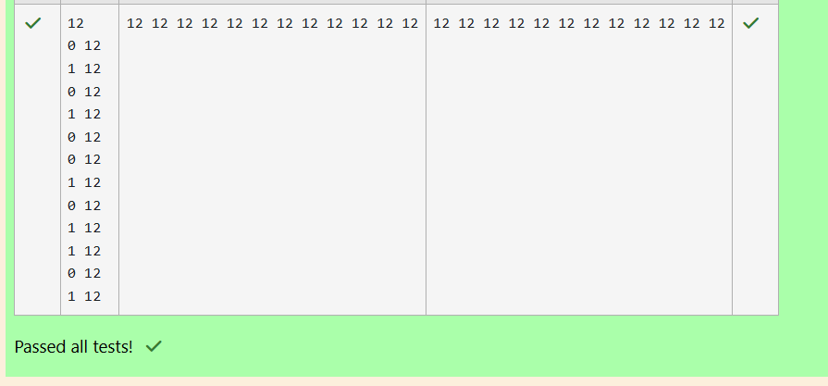
3. The Wealthy Landlord
Problem Statement:
Shyam Lal, a wealthy landlord from the state of Rajasthan, decided to partition his farmland into rectangular plots. Due to errors, some plots overlap, and he needs to compensate the farmers for the overlapping areas. Write a program to calculate the total compensation amount he should pay based on the overlapping area.
Input Format:
The first line contains an integer NNN—the number of plots.
Each of the next NNN lines contains five integers representing the coordinates of a rectangular plot (X1,Y1)(X1, Y1)(X1,Y1) and (X2,Y2)(X2, Y2)(X2,Y2), followed by the cost per unit area.
Output Format:
Print the total compensation amount.
Constraints:
1≤N≤1001 \leq N \leq 1001≤N≤100
1≤X1≤X2≤10001 \leq X1 \leq X2 \leq 10001≤X1≤X2≤1000
1≤Y1≤Y2≤10001 \leq Y1 \leq Y2 \leq 10001≤Y1≤Y2≤1000
1≤C≤10001 \leq C \leq 10001≤C≤1000
Sample Input:
Copy code
3
1 1 3 3 10
2 2 4 4 20
3 3 5 5 30
Sample Output:
yaml
Copy code
1100

